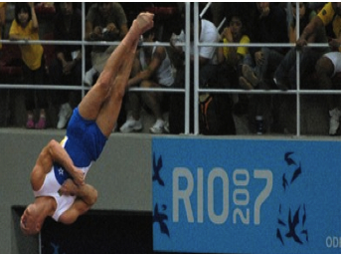
Nrich Solution - Zach Smallbone – Chatham Grammer School for Boys
130 Degrees
90 Degrees
180 Degrees

I got to this angle by drawing a x and y axis like in the photo and I drew a line through the person on the picture and using a virtual protractor measured the angle of the green line which came to 130 degrees.

