Hammer Throw Angles
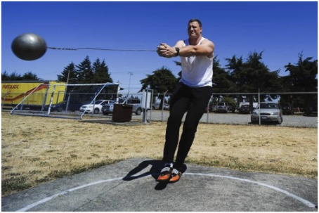
The man has to swing round numerous times to get the momentum and power behind the hammer. He must spin around about 4 times, that would be roughly about 1600 degrees but to get the power he may spin round more. His stance is at about 85 degrees from his legs to his arms, his legs go in about 5 degrees and leans back a bit.

