Squaring the Rectangle

The rectangle has length to width ratio 2:1. As an example the width is 1 cm and the length is 2 cm.

1
2

1

1 1

The area of the rectangle and square must be equal. In this case it must be 2 ${cm}^{2}$. The square has equal length sides and therefore the sides will have length $\sqrt{2} cm$.

If the second rectangle drawn is cut into four pieces, across the diagonal of each 1 x 1 square which is shown above, then the length of diagonals will be $1^{2}+1^{2}=a^{2}$ and thus $a=\sqrt{2}$.

The yellow triangle’s hypotenuse has length $\sqrt{2}$, which is the length of the square which will be constructed. A total of four yellow triangles can be cut out from the original rectangle and rearranged to create a square like this:

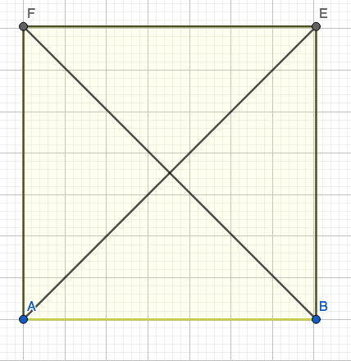

The triangles had length $\sqrt{2}$and two sides with length 1. The diagonal of the square is 2, which is equal to 2 times 1 cm, the width and half of the length of the previous rectangle.

This can be done with any triangle with ratio 2:1. Instead of the sides being 2 and 1 they can be called a and 2a. The area of the rectangle and square would then be $2a^{2}$. The sides of the square are $\sqrt{2}a$.

This formula can be proven with our example of sides 2 and 1. If 1 is a then the sides of the square is $\sqrt{2}*1=\sqrt{2}$

