Solution

- Let’s take a rectangle in 2:1 dimension.
Small side =x,
large side = 2x.

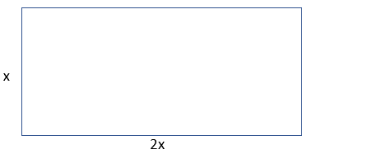

- Cut the longer side of the rectangle in half. Then cut the resulting two squares along the diagonal to make four right angle triangles isosceles as shown in the picture below.

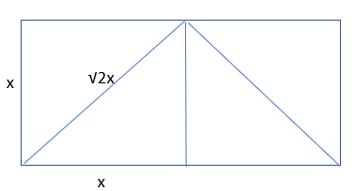

- The triangles formed are right angle triangles and using the Pythagoras theorem the length of the diagonal is calculated as,
Diagonal = √x² + √x²
= √2x

- To make a square arrange the triangle pieces as shown below. This works only for 2:1 rectangles.

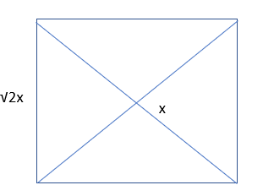

- The side of the square is √2x.

