I started solving with the first problem that is:
It's Jola's birthday and she is having a party. She has 24 cup-cakes to share equally between 3plates for the party. How many cakes will go on each plate?
My working out

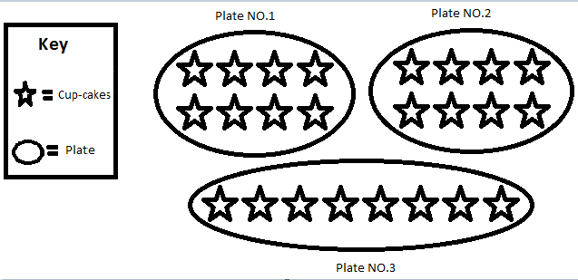

Therefore, there are 8 cup-cakes on each plate.
Next, I started with the second problem that is:
There are 8 children coming to the party. They are all going to the cinema. How many cars will they need to take them there? Each car will hold 4 children and they will each need a driver too.
My Answer and working out
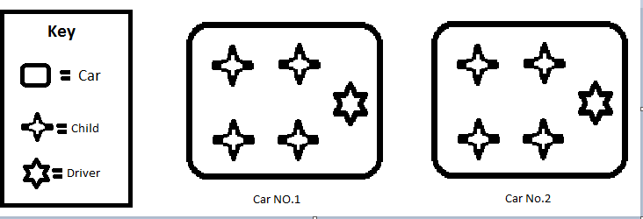
So, my answer is that there has to be two cars to go to the cinema.

Finally, I finished the last problem:
Jola is going to give everyone some chocolate eggs to take home at the end of the party. They fit into egg boxes which hold 6 eggs each. Will 50 eggs be enough for each of the 8 visitors to have a box to take home?
My Answer and working out

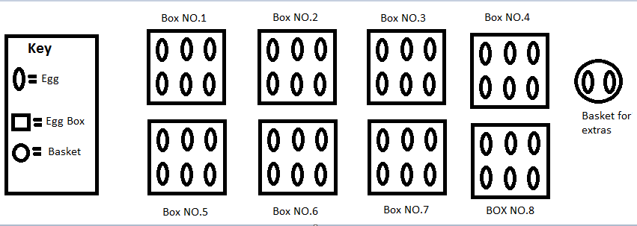
Every visitor will receive a box that contains 6 eggs but as it is shown on the diagram, there will be 2 eggs left over.

SWAATHI BALASUBRAMANIAN
Year 5, Class 5K
Garden International School
Kuala Lumpur
Malaysia

