Sticky Triangles
By Ethan, Dev, and Kevin,

We used three lolly sticks to make one small triangle. We added more lolly sticks to make four small triangles.
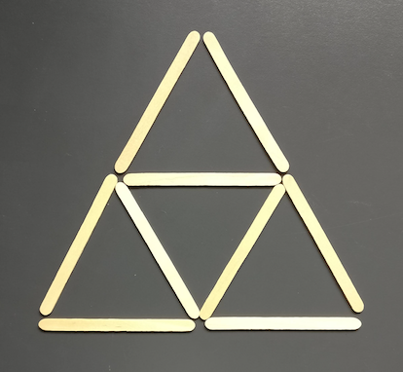

We investigated how many lolly sticks are used to make this pattern for different sized triangles.

We started by drawing a few more 'rows' of triangles and counted up how many lolly sticks there were.
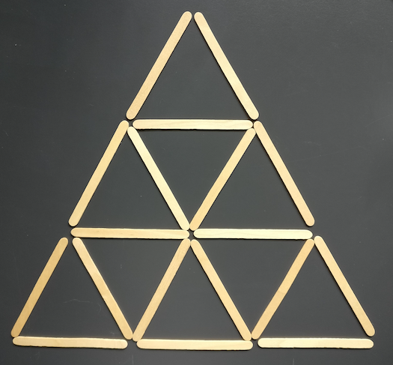
Here is a table with our results on:

Rows | Lolly sticks
1 | 3
2 | 9
3 | 18
4 | 30
5 | 45

We then made a table showing the number of rows and small triangles. We noticed it was the square numbers.

Rows | Small Triangles
1 | 1
2 | 4
3 | 9
4 | 16
m | ㎡

How we found a formula for a triangle that has m rows.
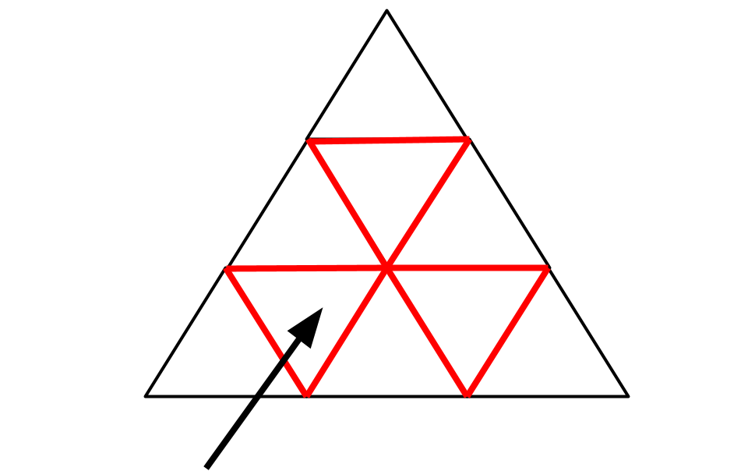
Each of the triangles has three lolly sticks so we did 3㎡.

The lolly sticks used to make the internal Triangles (the ones in red) have been doubled counted, but the lollysticks on the outside have not.

Now we add on the perimeter of the triangle so that all sides are double counted. The number of sticks on each side is m, so the perimeter of the big triangle is 3m.
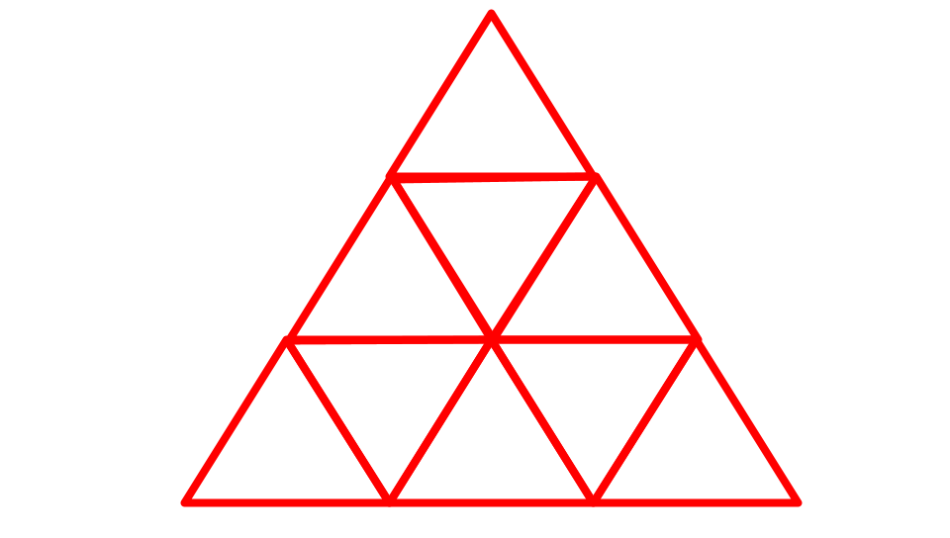
3㎡+3m

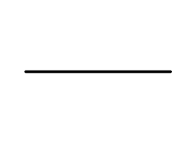
Finally we halved it. We do this because we double counted all the lolly sticks so to get the right amount we halve it.
So our formula looks like this: 3㎡+3m
2

