Felix’s parachute Jump

As Felix stepped from the capsule at a height of 39km, approximately what proportion of the Earth's surface could he see?

Assumptions
- Earth is a perfect sphere
- Radius of Earth 6731km (http://en.wikipedia.org/wiki/Earth_radius)
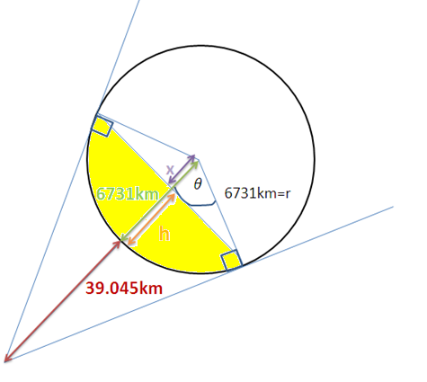
By considering his field of vision to be a spherical cap and then looking at the cross section of the earth we get the diagram shown above. Felix starts at the point where the two tangents meet and his area of vision is the part shaded in yellow. In order to find the surface area of this spherical cap we need to know the distance $h.$
$$\cos\left(θ\right)=\frac{a}{h}=\frac{6731}{39.045+6731}$$
To find length $x:$
$$\cos\left(θ\right)=\frac{a}{h}=\frac{x}{6731}$$
$$x=\cos\left(θ\right)×6731$$
$$x=6731×\frac{6731}{39.045+6731}= 6692.180185$$
To find $h:$
$$h=6731-x$$
$$h=38.81981508$$
To find the area of the spherical cap:
$$Area=2πrh$$
$$=2π×6731×38.81981508$$
$$=1641772.29{km}^{2}$$
The surface area of the earth:
$$A=4πr^{2}$$
$$=4π {\left(6731\right)}^{2}$$
$$=569336523.5$$
Therefore proportion he can see=
$$=\frac{1641772.29{km}^{2}}{569336523.5km^{2}}$$
$$=0.002883658824$$
$$=0.002884 (4dp)$$

Felix landed 9 minutes and 3 seconds after jumping. How much quicker would an object in freefall all the way down (ie without a parachute) land?

Assuming:
- Air resistance is negligible (we could say that this is reasonable because the very low air pressure at these high altitudes)
- Acceleration 9.81$ms^{-2}$ is constant for the whole flight time
$$S=39045m$$
$$u=0 ms^{-1}$$
$$v=?$$
$$a=9.81ms^{-2}$$
$$t=?$$

Using:
$$s=ut+\frac{1}{2}at^{2}$$
$$39045=\frac{1}{2}×9.81 ×t^{2}$$
$$t^{2}=7960.244648$$
$$t=89.22020314s$$
Therefore an object falling at free-fall would reach the ground in approximately $1min 29.2 seconds$
Approximately $452.8 seconds$ faster than Felix

Can you estimate the maximum speed Felix reached before opening his parachute after 4 minutes and 19 seconds of freefall?

Assumptions:

- Air resistance is negligible (we could say that this is reasonable because the very low air pressure at these high altitudes)
- Acceleration 9.81$ms^{-2}$ is constant for the whole flight time
$$S=?$$
$$u=0 ms^{-1}$$
$$v=?$$
$$a=9.81ms^{-2}$$
$$t=259s$$
Using:
$$v=u+at$$
$$v=0+9.81×259$$
$$v=2540.29ms^{-1}$$
Therefore his final speed is approximately $2540ms^{-1}$ (3sf).

