The Dice Train Challenge
Students from the Year 3 Mathematics Extension Program (MEP) at Lumen Christi Primary School attempted the Dice Train Challenge. Having previously attempted the Add Three Dice Challenge we were confident of finding multiple solutions to this problem.
To begin we used different sized six-sided dice from around the Mathematics resource room and began trying various combination. After checking to see if each train met the two criteria we took a photo of the finished product.
After a while we decided to develop a recording system to ensure we were not repeating any combinations.
Top of the Funnel | Top of the Carriages | Photo
6 | 3, 3 | 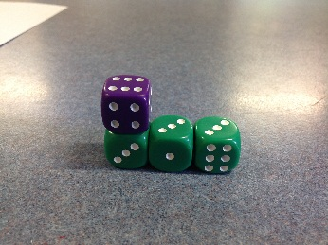
6 | 1, 5 | 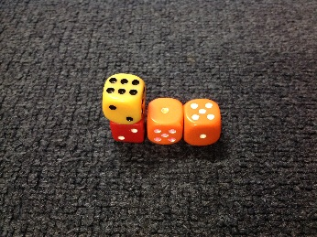
5 | 2, 3 | 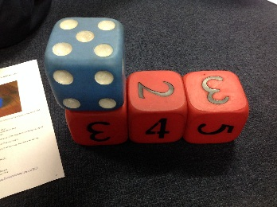
4 | 2, 2 | 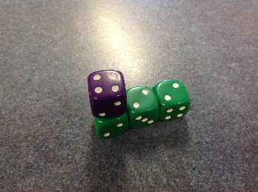
4 | 3, 1 | 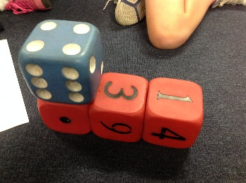
4 | 1, 3 | 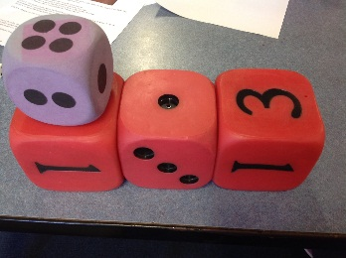
2 | 1, 1 | 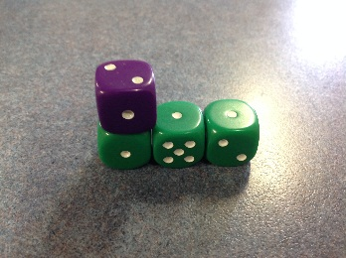

Hayden began investigating finding solutions that involved using more carriages. Soon other students took up this challenge.
Top of the Funnel | Top of the Carriages | Photo
3 | 1, 1, 1 | 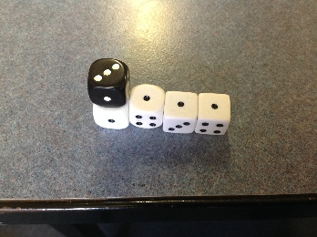
4 | 1, 1, 1, 1 | 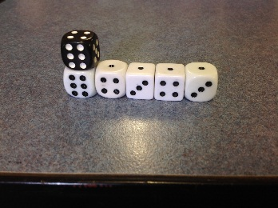
5 | 1, 2, 2 | 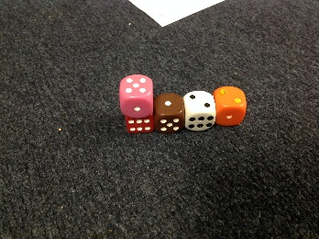
5 | 2, 2, 1 | 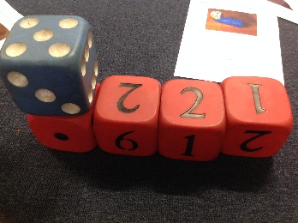
6 | 2, 2, 2 | 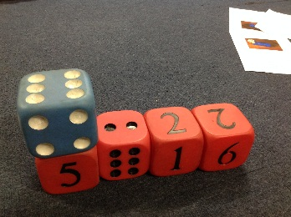
6 | 2, 1, 2, 1 | 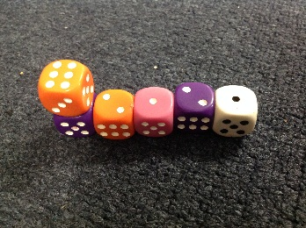
6 | 2, 2, 1, 1 | 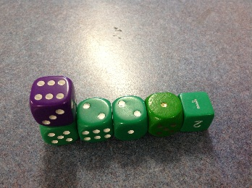
6 | 1, 3, 1, 1 | 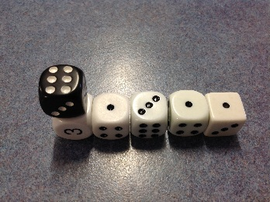
6 | 1, 4, 1 | 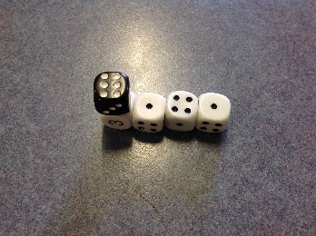
6 | 1, 1, 4 | 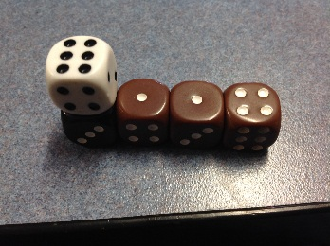
6 | 1, 1, 1, 1, 1, 1 | 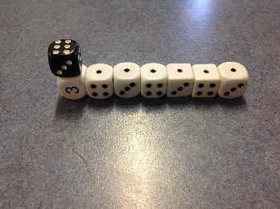

Hayden explained to the group that the final combination above: 6 – 1, 1, 1, 1, 1, 1 is the longest train that can be created using the initial criteria of having 6-sided dice.
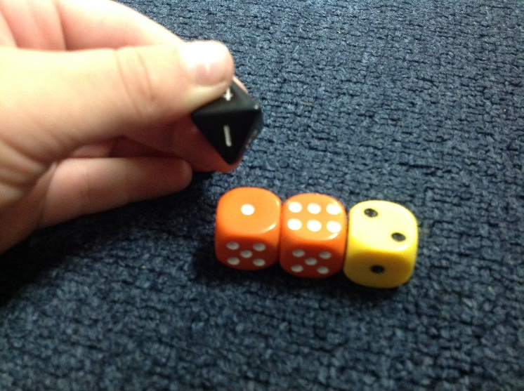
From here, students began to extend the problem by investigating whether or not they could find any solutions that still fulfilled the criteria, but used more dice or at least one dice that had more than 6 sides. Flynn was able to find and justify the first solution and soon other students followed. Flynn explained that under the black 8 is a 1, which matches with the 1 on the orange dice.
Top of the Funnel | Top of the Carriages | Photo
8 | 6, 2 | 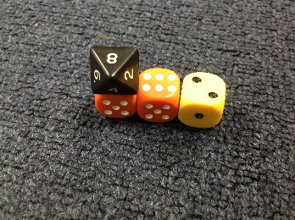
8 | 1, 1, 1, 1, 1, 1, 1, 1 | 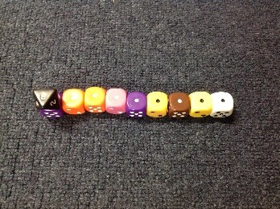
7 | 3, 4 | 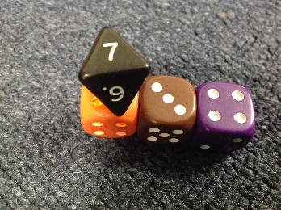
12 | 6, 6 | 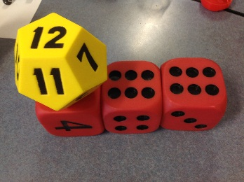
12 | 5, 2, 5 | 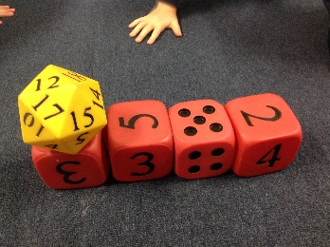
14 | 6, 4, 4 | 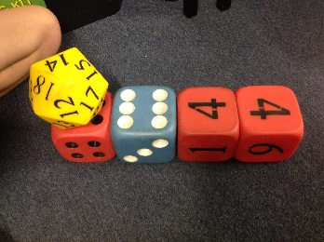
15 | 5, 5, 5 | 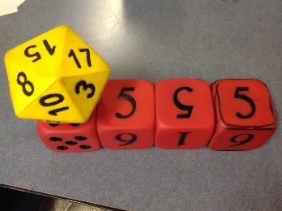
17 | 4, 4, 4, 5 | 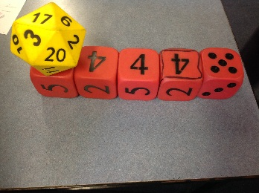
19 | 4, 5, 5, 5 | 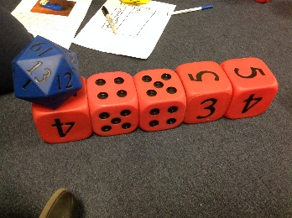
20 | 5, 5, 5, 5 | 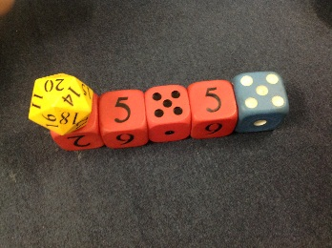

Julian suggested we could make a train that met the criteria, but had a taller funnel.
Top of the Funnel | Top of the Carriages | Photo
6 | 5, 1 | 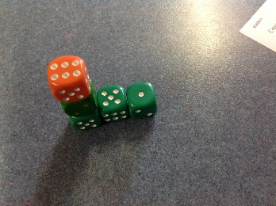
6 | 4, 1, 1 | 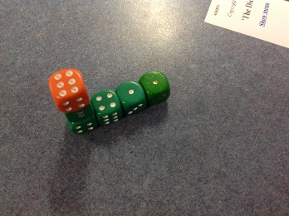
6 | 3, 1, 1, 1 | 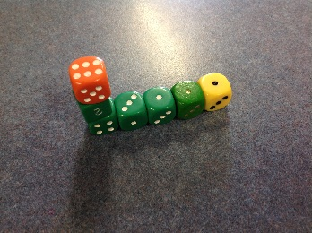

This suggestion prompted Jerusha to create a train that fulfilled the criteria, but had a wider funnel.
Top of the Funnel | Top of the Carriages | Photo
6 + 6 = 12 | 5 + 5 + 2 = 12 | 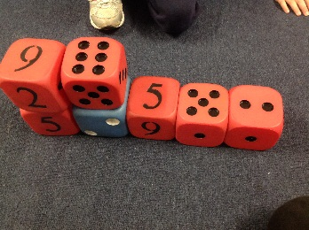

All up we found 18 solutions to the original problem and 14 solutions to different variations of the problem.

