I have a simple yet affective solution for strange bank account:

£6 - £3 + £2 = £5

I know that this may be simple but it does give you a quick and simple solution. So it could be used for an example on the website to show a simple version of the strange bank account.
I got this answer by following the instructions from online.
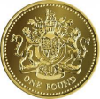
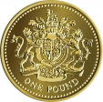
If you have £6:

Then takeaway £3:

Then add £2:

You end up with £5 which is how I understand this easy problem.
I also found a formula for the general proceed of getting £5 in Alison’s bank account.
(3n +1) X £2 = 2n – 1 x £3 = £5
I worked this out by taking 1 object and then following the formula so 3 objects + 1 times 2 which equalled 8 and then 2 objects – 1 then times 3 which equalled 3. However they didn’t equal the same thing so this number would not work but others could.

